# **Induction Process Using Chatbot**

To digitalize Induction Process

### **Prerequisites**

-For the project we need

-python 3.7

-Rasa Framework install by the following command

-pip install rasa

-MongoDB for Database

## **Getting Started**

-For running the chatbot local machine do the following

-Be in project directory

-Start action server by using the command

-rasa run actions

-Run the chatbot in debug mode by using the following command

-rasa shell --debug

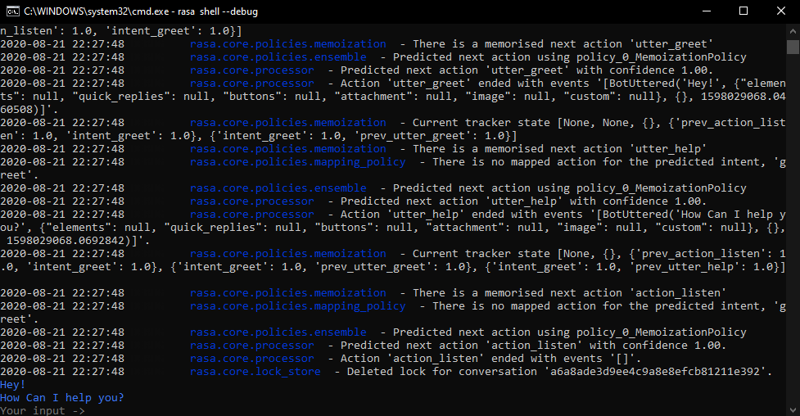

ChatBot in debug mode

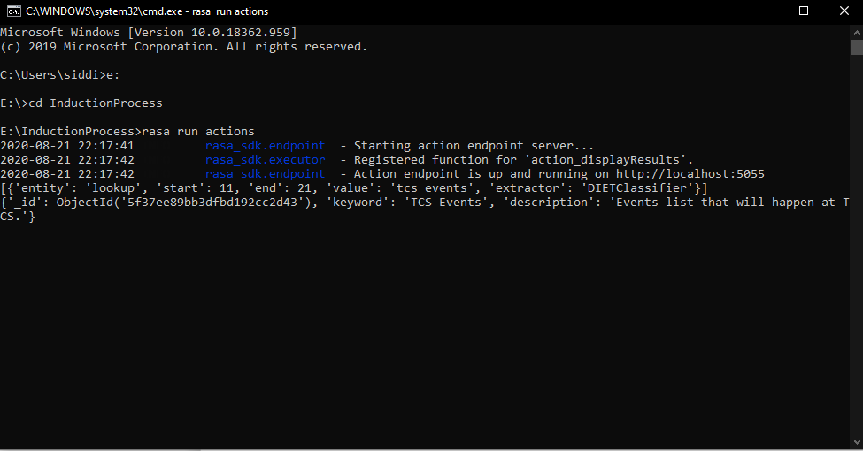

Rasa Action Server

-For adding search keywords in lookup file(i.e. documents & video titles etc) update the lookup.txt file ./data/lookup

-Schema of the mongodb Document:

{

"_id": { "bsonType": BSON.ObjectId() }

"keyword": {"bsonType": "string"},

"description":{"bsonType": "string"}

}

-Adding a document:

{

"_id":{"$oid":"5f37ef25bb3dfbd192cc2d45"},

"keyword":"Search Keyword you want to add i.e. video/document title",

"description":"That video link"

}

-For adding Western Union Description update utter_displayAbouWU text in Domain.yml file

### **Installing**

-To run the command line app follow the instructions

-Be in project directory

-Start action server by using the command

-rasa run actions

-Run the chatbot in debug mode by using the following command

-rasa shell --debug

-Start the Rasa Chatbot Server By running the following command

-rasa run -m models --endpoints endpoints.yml --port 5002 --credentials credentials.yml(specify port where you want to run rasa server)

-Run Chatbot.py

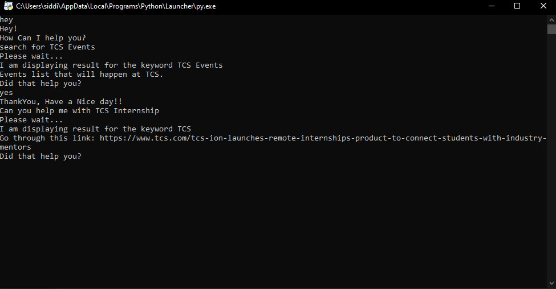

Chatbot.py

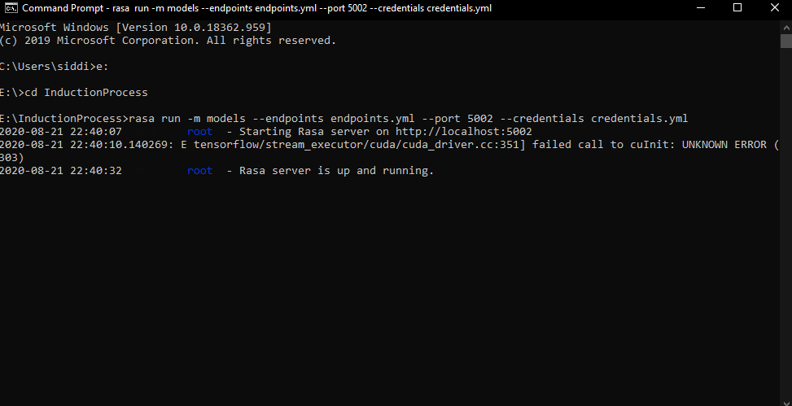

Rasa Server

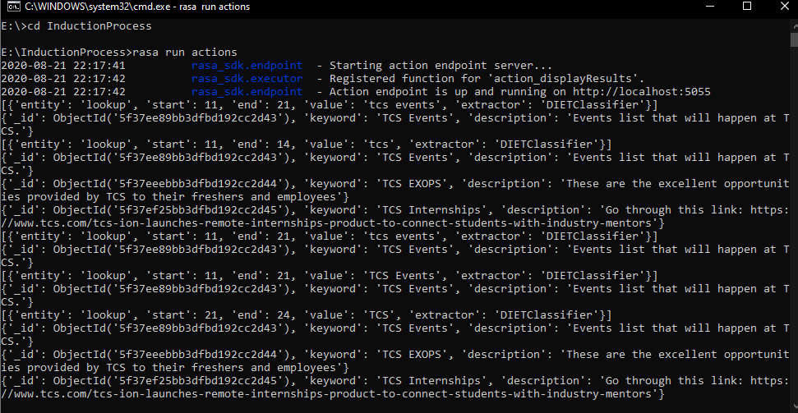

Rasa Actions Server

## **Built With**

* [Rasa](https://rasa.com/docs/) - The Chatbot Framework
* [MongoDB](https://api.mongodb.com/python/current/tutorial.html) - For Database